1-→Club.java

**A method which accepts a string as an argument and returns the first letter of every word clubbed into a string**

public class Club

{

public char[] methodClub(String str1)

{

char[] result = str1.toCharArray();

char[] ch = new char[result.length];

ch[0]=str1.charAt(0);

int k=1;

for (int i=1;i<result.length;i++)

{

if(result[i]==' '){

ch[k++] = str1.charAt(i+1);

}

}

return ch;

}

public static void main (String[] felight)

{

Club c = new Club();

char[] ch= c.methodClub("kello Iam Vidhya Raja");

for(int i=0;i<ch.length;i++)

{

System.out.println(ch[i]);

}

}

}

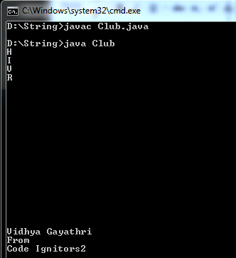

2)→ReverseString.java

**Method to reverse a string a string without using StringBuffer or StringBuilder**

class ReverseString{

static char[] reverseString (String str)

{

char[] result= str.toCharArray();

char[] reverse = new char[str.length()];

for(int i=1;i<=str.length();i++)

{

reverse[i-1]=result[str.length()-i];

}

return reverse;

}

public static void main(String[] Felight)

{

System.out.println(reverseString("Felight"));

System.out.println("\nVidhya Gayathri\nFrom\nCode Ignitors2");

}

}

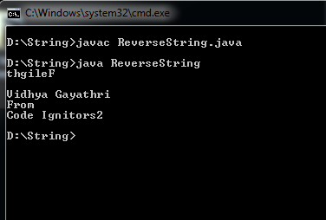

3)→Email.java

**Method which returns true if the email address is valid**

class Email{

public static void main(String[] args) {

String EMAIL_REGEX = "^[\\w-_\\.+]*[\\w-_\\.]\\@([\\w]+\\.)+[\\w]+[\\w]$";

String email1 = "[user@domain.com](mailto:user@domain.com)";

Boolean b = email1.matches(EMAIL_REGEX);

System.out.println("is e-mail: "+email1+" :Valid = " + b);

}

}

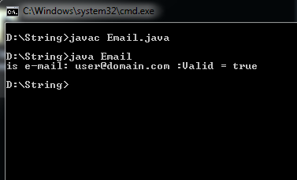

4→Movie.java

**Method which returns the rating of the movie**

import java.util.Scanner;

class Movie{

public static void main(String[] args)

{

Scanner sc = new Scanner(System.in);

String rev= sc.nextLine();

//String rev= "was good splendid not bad worst stupid dirty was bad";

//String[] arr= rev.split(" ");

//for(String s: arr){

// System.out.print(s + " ");

//}

int GC=0, BC=0;

if(rev.contains("was good")||rev.contains("too good")||rev.contains("is good"))

GC+=1;

if(rev.contains("amazing"))

GC+=1;

if(rev.contains("better"))

GC+=1;

if(rev.contains("not bad"))

GC+=1;

if(rev.contains("splendid"))

GC+=1;

if(rev.contains("was bad")||rev.contains("too bad")||rev.contains("is bad"))

BC+=1;

if(rev.contains("worst"))

BC+=1;

if(rev.contains("not good"))

BC+=1;

if(rev.contains("stupid"))

BC+=1;

if(rev.contains("dirty"))

BC+=1;

if(GC>=1 && BC<=4){

switch(GC){

case 1: System.out.println("Rating :"+"1/5");

break;

case 2:System.out.println("Rating : "+"1.5/5");

break;

case 3: System.out.println("Rating :"+"2/5");

break;

case 4: System.out.println("Rating :"+"2.5/5");

break;

case 5: System.out.println("Rating :"+"3/5");

break;

default:System.out.println("Rating :"+"1/5" );

break;

}

}

else if (BC>4)

{

System.out.println("BC--Rating :"+"1/5");

}

}

}

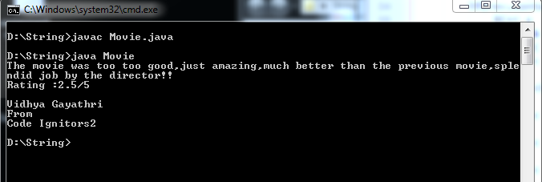

5→RepeatAA.java

**Program to replace ‘A’ with ‘AA’ and if ‘a’ is followed by ‘s’ then do not do anything**

class RepeatAA {

public static void main(String[] Felight)

{

String str="It was a fine evening as I approched to the ...";

System.out.println(str);

String str1;

str1=str.replaceAll("a", "aa") ;

System.out.println( str1.replaceAll("aas","as"));

}

}

6)→Fr.java

**First repeating character and return it**

class Fr{

public static void main(String[] Felight)

{

String input="Googgle books ccookss";

System.out.println(input);

char[] arr=input.toCharArray();

System.out.println(arr);

char[] r= new char[100];

int k=0;

for(int i=0;i<arr.length-1;i++)

{

if(arr[i]==arr[i+1])

{

r[k++]=arr[i];

}

}

System.out.println(r);

}

}

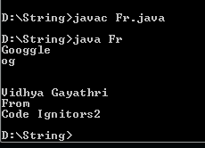

7)Hrc.java

**Highest repeating character**

class Hrc{

public static void main(String args[])

{

String str="dlylr";

char[] array = str.toCharArray();

int count = 1;

int max = 0;

char maxChar = 0;

for(int i=1; i<array.length; i++)

{

if(array[i]==array[i-1])

{

count++;

}

else

{

if(count>max)

{

max=count;

maxChar=array[i-1];

}

count =2;

}

}

if(count>max){

max=count;

maxChar=array[array.length-1];

}

System.out.println("highest repeating character is "+maxChar);

}

}

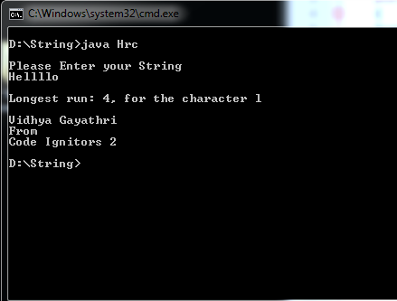

8) Anagrams.java

**Check if two strings are anagrams of each other → Army & Mary are anagrams of each other**

import java.util.Scanner;

class Anagrams

{

public static void main (String[] Felight)

{

Scanner input = new Scanner(System.in);

System.out.println("\nEnter the first String :");

String str1 = input.nextLine();;

System.out.println("\nEnter the second String :");

String str2= input.nextLine() ;

char[] ch1=str1.toCharArray();

char[] ch2=str2.toCharArray();

if(ch1.length==ch2.length)

{

for(int i=0;i<ch1.length-1;i++)

{

for(int j=1;j<ch1.length-1;j++)

{

if(ch1[i]==ch2[j])

{

char var=ch1[i];

}

}

}

System.out.println("\nThe Strings are anagrams of each other!!");

}

else

{

System.out.println("\nTheir lengths are not eqaul!! \n\nHence not an anagram!!");

}

System.out.println("Vidhya Gaythri\nFrom \nCode Ignitors 2");

}

}

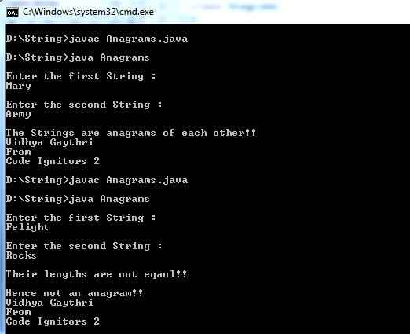

9)Duplicate.java

**Duplicate characters in a string → a:2 g:2 m:1**

import java.util.Scanner;

class Duplicate{

public static void main(String[] args)

{

Scanner input = new Scanner(System.in);

System.out.println("Enter your string");

String str = input.nextLine();

char[] ch = str.toCharArray();

int count = 0;

for(int k=0,j=1;k<ch.length;k++,j++)

{

char c= str.charAt(k);

count=0;

for(int i=0;i<ch.length;i++)

{

if(c==ch[i])

{

count+=1;

}

}

System.out.println(c+":"+count);

}

System.out.println("Vidhya Gayathri\nfrom\nCode Ignitors 2");

}

}

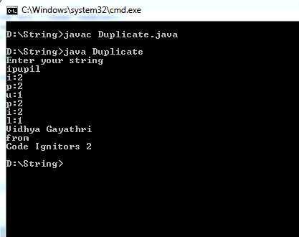

**Is String a palindrome**

import java.util.*;

class Test

{

public static void main(String args[])

{

String original, reverse = "";

Scanner in = new Scanner(System.in);

System.out.println("Enter a string to check if it is a palindrome");

original = in.nextLine();

int length = original.length();

for ( int i = length - 1; i >= 0; i-- )

reverse = reverse + original.charAt(i);

if (original.equals(reverse))

System.out.println("Entered string is a palindrome.");

else

System.out.println("Entered string is not a palindrome.");

}

}

